Objective:- Blog Application using Firebase

Code :-

- Lib

- models
- blog.dart

class Blog {
String? title;
String? description;
String? id;
Blog({this.title, this.description, this.id});
}

- services

- firebase_services.dart

import 'package:cloud_firestore/cloud_firestore.dart';
import '../models/blog.dart';

class FirebaseServices {
var db = FirebaseFirestore.instance;
addBlog(String title, String description) {
// Create a new note with a title and description
final note = <String, dynamic>{"title": title, "description": description};

// Add a new document with a generated ID
db.collection("blog").add(note).then((DocumentReference doc) =>
// ignore: avoid_print
print('DocumentSnapshot added with ID: ${doc.id}'));
}

Stream<QuerySnapshot> fetchBlog() {
Stream<QuerySnapshot> collectionStream =
FirebaseFirestore.instance.collection('blog').snapshots();
return collectionStream;
// Stream documentStream = FirebaseFirestore.instance.collection('users').doc('ABC123').snapshots();
}

updateBlog(Blog blog) {
return db
.collection("notes")
.doc(blog.id)
.update({'title': blog.title, 'description': blog.description})
// ignore: avoid_print
.then((value) => print("Note Updated"))
// ignore: avoid_print
.catchError((error) => print("Failed to update Note: $error"));
}

deleteBlog(id) {
return db
.collection("blog")
.doc(id)
.delete()
// ignore: avoid_print
.then((value) => print("User Deleted"))
// ignore: avoid_print
.catchError((error) => print("Failed to delete user: $error"));
}
}

- screen
- blog_details_screen.dart

import 'package:flutter/material.dart';

import '../models/blog.dart';
import '../services/firebase_services.dart';

class BlogDetailsScreen extends StatefulWidget {
final Blog? blog;
const BlogDetailsScreen({super.key, this.blog});
@override
State<BlogDetailsScreen> createState() => _BlogDetailsScreenState();
}

class _BlogDetailsScreenState extends State<BlogDetailsScreen> {
final _formKey = GlobalKey<FormState>();
late String _title;
late String _content;

@override
void initState() {
super.initState();
if (widget.blog != null) {
_title = widget.blog!.title!;
_content = widget.blog!.description!;
} else {
_title = '';
_content = '';
}
}

void _saveBlog() {
if (_formKey.currentState!.validate()) {
_formKey.currentState!.save();
// final blog = Blog(
// id: widget.blog?.id,
// title: _title,
// description: _content,
// );
//todo code to store on firestore
FirebaseServices().addBlog(_title, _content);
Navigator.pop(context);
}
}

@override
Widget build(BuildContext context) {
return Scaffold(
appBar: AppBar(
title: Text(widget.blog == null ? 'New Blog' : 'Edit Blog'),
),
body: Padding(
padding: const EdgeInsets.all(16.0),
child: Form(
key: _formKey,
child: Column(
children: [
TextFormField(
initialValue: _title,
decoration: const InputDecoration(labelText: 'Title'),
validator: (value) {
if (value == null || value.isEmpty) {
return 'Please enter a title';
}
return null;
},
onSaved: (value) {
_title = value!;
},
),
const SizedBox(height: 16.0),
TextFormField(
initialValue: _content,
decoration: const InputDecoration(labelText: 'Content'),
validator: (value) {
if (value == null || value.isEmpty) {
return 'Please enter content';
}
return null;
},
onSaved: (value) {
_content = value!;
},
),
const SizedBox(height: 16.0),
ElevatedButton(
onPressed: _saveBlog,
child: const Text('Save'),
),
],
),
),
),
);
}
}

- blog_list_screen.dart

import 'package:cloud_firestore/cloud_firestore.dart';
import 'package:flutter/material.dart';
import 'package:blog_app/services/firebase_services.dart';

import '../models/blog.dart';
import 'blog_details_screen.dart';

class BlogListScreen extends StatelessWidget {
const BlogListScreen({super.key});

@override
Widget build(BuildContext context) {
return Scaffold(
appBar: AppBar(
title: const Text('Blog'),
),
body: StreamBuilder<QuerySnapshot>(
stream: FirebaseServices().fetchBlog(),
builder: (BuildContext context, AsyncSnapshot<QuerySnapshot> snapshot) {
if (snapshot.hasError) {
return const Text('Something went wrong');
}

if (snapshot.connectionState == ConnectionState.waiting) {
return const Center(child: CircularProgressIndicator());
}

if (!snapshot.hasData ||
snapshot.data == null ||
snapshot.data!.docs.isEmpty) {
return const Text("No Blog found");
}

return ListView(
children: snapshot.data!.docs.map((DocumentSnapshot document) {
Map<String, dynamic>? data =
document.data() as Map<String, dynamic>?;

if (data == null) {
return const ListTile(
title: Text('No Data'),
);
}

// Safely handle null for title and description
String title = data['title'] ?? 'Untitled';
String description = data['description'] ?? 'No description';

Blog blog = Blog(
id: document.id,
title: title,
description: description,
);

return ListTile(
title: Text(blog.title!),
subtitle: Text(blog.description!),
trailing: Row(
mainAxisSize: MainAxisSize.min,
children: [
IconButton(
icon: const Icon(Icons.edit, color: Colors.blue),
onPressed: () {
// Navigate to edit blog screen
Navigator.of(context).push(MaterialPageRoute(
builder: (context) => BlogDetailsScreen(blog: blog),
));
},
),
IconButton(
icon: const Icon(Icons.delete, color: Colors.red),
onPressed: () {
// Confirm deletion before deleting
showDialog(
context: context,
builder: (BuildContext context) {
return AlertDialog(
title: const Text("Delete Blog"),
content: const Text(
"Are you sure you want to delete this blog?"),
actions: [
TextButton(
onPressed: () => Navigator.of(context).pop(),
child: const Text("Cancel"),
),
TextButton(
onPressed: () {
FirebaseServices().deleteBlog(document.id);
Navigator.of(context).pop();
},
child: const Text("Delete"),
),
],
);
},
);
},
),
],
),
);
}).toList(),
);
},
),
floatingActionButton: FloatingActionButton(
onPressed: () {
Navigator.of(context).push(MaterialPageRoute(
builder: (context) => const BlogDetailsScreen()));
},
child: const Icon(Icons.add),
),
);
}
}

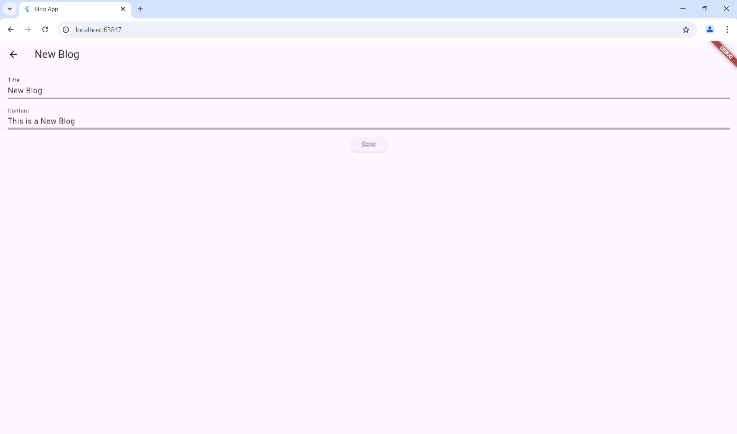
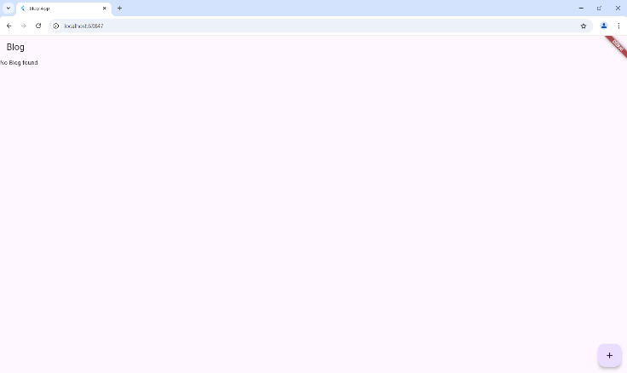
Output:-
